Early keyboard Cloth
(Walker cloth)
Information for 2026
We are the distributors of the action cloth that Graham Walker researched. This cloth is now recognised as the most appropriate replacement in period keyboard instruments, not only for early pianos but for many other instruments such as harpsichords, spinets, clavichords and fortepianos. They are used by makers, restorers, and museum curators in the UK, and many other countries. All cloths have 100% wool composition.
They are manufactured as near as possible to neutral acidity that may be a requirement where instruments are held by museums. The 2.5mm Early Keyboard Cloth has an acidity level of 6.2pH. (Measured by the manufacturer and based on a sample). Other cloths have been manufactured to achieve a typical acidity level of between 5.0pH and 6.0pH (neutral acidity is 7.0pH).
As may be expected, the qualities and thicknesses of cloth originally used in early pianos and other period keyboard instruments varied and therefore a range of cloths have been replicated to meet requirements. If you are unsure about which cloths to use, you can email me at cesar@fortepiano.co.uk for advice. Please be aware that colours may look slightly different depending on your screen.
Walker green cloth is available in 1.5mm and 2.5mm thickness (measures are approximate and dependent on the way it is measured) and is a close match in weight, composition and colour to the original cloth found in early English square and grand pianos and other early keyboards. It can be used for the back-touch, balance rail, front rail, hammer rail and elsewhere in keyboard actions. The 2.5mm cloth is made from a coarser wool yarn and is often used by harpsichord makers. It is also suitable for later pianos and other early keyboard instruments.

GREEN ACTION CLOTH

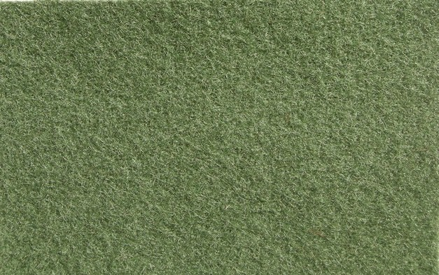

Prices:
For the green 1.5mm thick cloth
- 25 cm x 145 cm (roll width) - usually enough for one instrument – £44
- 50 cm x 145 cm (roll width) - £77
- 100 cm wide x 145cms (roll width) – £130

For the green 2.5 mm thick cloth:
- 25 cm x 130 cm (roll width) - usually enough for one instrument - £44
- 50 cm wide x 130cm (roll width) - £77
- 100 cm wide x 130 cm (roll width) £130
RED CLOTH
Hitch-pin worsted bearing cloth (Broadwood Type)

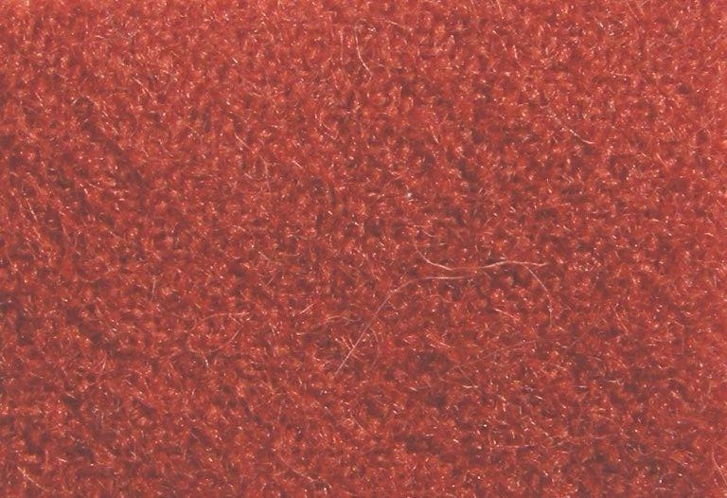
The cochineal red hitch-pin worsted bearing cloth has a worsted weave. The roll width is approximately 152cm (60 inches). It has been replicated from the cloth found in early 19th century Broadwood square pianos. The cochineal colour is a typical shade. This cloth is an excellent match to the original hitch-pin bearing cloth used in square pianos made by Broadwood and some other makers. It has a similar worsted weave to the original and the shade of cochineal colour is typical of the cloth found in these instruments.
Prices:

- 10 cm x 140 cm wide (roll width) – usually enough for one instrument - £24.5
- 25 cm x 140 cm wide (roll width) – £43
- 50 cm x 140 cm wide (roll width) – £75
- 100 cm x 140 cm wide (roll width) – £130

DAMPER CLOTH
We have available red and white woollen cloth in 1 mm thickness. It is slightly more cherry in colour than the cochineal Worsted bearing cloth.
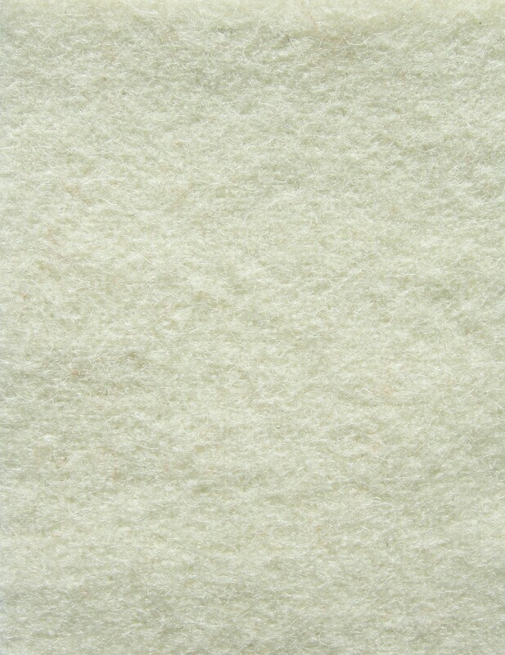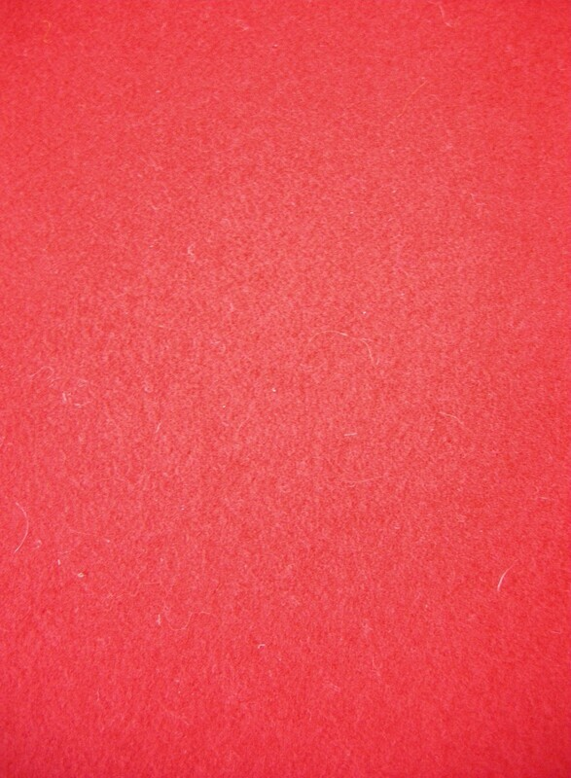
Prices and sizes for white damper cloth:
- 10 cm x 135 cm wide (roll width) - £28
- 25 cm x 135 cm wide (roll width) - £58.50
- 50 cm x 135 cm wide (roll width) - £95

Prices and sizes for red damper cloth:
- 10 cm x 150 cm wide (roll width) - £28
- 25 cm x 150 cm wide (roll width) - £58.50
- 50 cm x 150 cm wide (roll width) - £95

